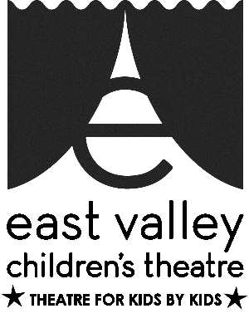
PROGRAM VIDEOGRAPHER
AT EAST VALLEY CHILDREN’S THEATRE

Purpose & Impact:
Use video clips and photography to generate interest and excitement for EVCT programs and events. Provide marketing with material to create engaging posts for social media and other media outlets.
Scope of Work:
The program videographer collects footage from classes, events, and rehearsals. They create video interviews of program participants (students and parents) and staff. Footage is edited to produce targeted footage for marketing and media use to engage the audience and promote EVCT’s award winning programs.
Skills and Attributes :
Knowledge and experience in types, trends, and uses of visual media. Videographer would need to own appropriate equipment and editing tools. Should be able to put subjects at ease and draw out participants’ enthusiasm for EVCT. Able to work with others and meet deadlines.
Timeframe/Schedule:
Full season (12 months). Production schedule would vary with season schedule. Targeted project schedule possible. Deadlines are crucial.
Work Environment:
Videographer would work closely with the Artistic Director, Office/Business Manager and Marketing Director to determine target projects and content focus.
Work Space:
Work could be on-site or off-site. Some flexibility in hours. Footage shoots are coordinated with studio management and the marketing director.
Transportation:
Will need to provide their own transportation if off-site video footage is required. The office location offers abundant free parking, and is conveniently located on bus lines, with direct connections to the light rail and the Superstition Springs Transit Center. Our office is ADA accessible.
Benefits:
EVCT would provide Theatre tickets, discounted classes, and acknowledge production credit.

