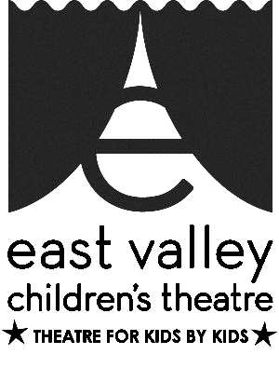
Fund Development Coordinator
AT EAST VALLEY CHILDREN’S THEATRE

Description:
The Fund Development Coordinator would chair the fund development committee in fund raising activities, and assess which are worthwhile and would be most effective for the Theatre.

Purpose and Impact:
A Fund Development Coordinator is necessary for our organization, in order to increase public understanding of our mission and acquire financial support for our programs. Because our goal is to provide youth a forum for building career and life skills, this role is critical to our organizational sustainability in developing a sound foundation of financial sources to support our productions, classes, troupes and special interest activities.

Scope of Work:
This individual would chair and oversee current revenue streams and fundraising campaigns and assess new funding sources. The Fund Development Coordinator would work with the Marketing Director to create materials to engage funders.

Skills and Attributes:
EVCT is looking for someone who has worked in fund or entrepreneurial development programs, or someone who is willing to take on a new challenge. It would be helpful, but not essential, to be familiar with applicable software and technology and possesses great communication skills.

Timeframe/Schedule:
The job would last for one season at the EVCT (12 months) with flexible hours.

Work Environment:
The Coordinator would work directly with Artistic Director, Board President, Marketing Director, Office/Business Manager and Board Treasurer. EVCT is organized, with clear expectations and is eager to make a difference in the lives of children. The work environment is warm, welcoming and dedicated.

Work Space:
Work could be done on-site or off-site with flexible hours. The EVCT office could be used, including computer, printer, software and files necessary, desk and chair and is available during daytime hours between 9 am and 5 pm.

Transportation:
Our office location offers abundant free parking, and is conveniently located on bus lines, with direct connections to the light rail and the Superstition Springs Transit Center. Our office is ADA accessible.

Benefits:
The theatre would offer theatre tickets, backstage tour tickets, and discounted classes, as well as a great addition to any resume.

