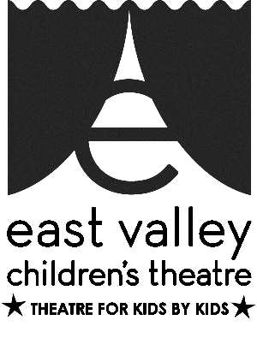
IT SUPPORT
AT EAST VALLEY CHILDREN’S THEATRE

Description:
The IT support volunteer would identify needed equipment and software to be purchased and installed to insure that the theatre is running efficiently with all programs easily accessed and utilized by all staff.

Purpose and Impact:
East Valley Children’s Theatre is an award-winning theatre entering its 20th year of entertaining audiences and teaching children confidence and life skills. In order to continue this important work, we need an IT Support Volunteer that can bring our software and technology up to date.

Scope of Work:
Our IT Support volunteer will identify, install and deploy software to meet our needs, and manage software compatibility and integration. He/she will train volunteers to use the new software, including producing an operation manual for continuity, and FAQs for end users. This individual will evaluate hardware and computer needs and make recommendations.

Skill and Attributes:
EVCT’s IT Support Volunteer will need to have in-depth familiarity with a variety of software: volunteer management, including scheduling, tracking, communication, and messaging; donor and client tracking; accounting; data security; and marketing. The IT Support will use creativity to problem solve and will have good communications skills across generations.

Timeframe/Schedule:
We would ideally want to have this volunteer commit to working with EVCT for 12 months, but scheduling is negotiable.

Work Environment:
As IT Support Volunteer, you’ll be working directly with EVCT’s Office/Business Manager, Artistic Director and Webmaster. Software expenditures will need to be approved by the board. EVCT is organized with clear expectations, and eager to make a difference in children’s lives. We have a wide age range of vibrant volunteers working with us, and you’ll enjoy working in our warm, welcoming, committed environment.

Work Space:
We offer flexible hours, working on-site or off-site. The EVCT office is available during daytime hours 9am to 5 pm, and you’ll have Wi-Fi access to our computer and printer, with a comfortable chair and desk.

Transportation:
Our office location offers abundant free parking, and is conveniently located on bus lines, with direct connections to the light rail and the Superstition Springs Transit Center. Our office is ADA accessible.

Benefits:
To show our gratitude, you’ll enjoy theatre tickets to our award-winning shows, backstage tours, and discounts for our classes. We express our appreciation freely and hold an annual thank you event to spotlight personal recognition.

